EXP 8: **SOFTWARE PERSONAL MANAGEMENT**

**AIM** : To draw uml diagram for software personal managment using umbrello.

**COLLABRATION DIAGRAM :**

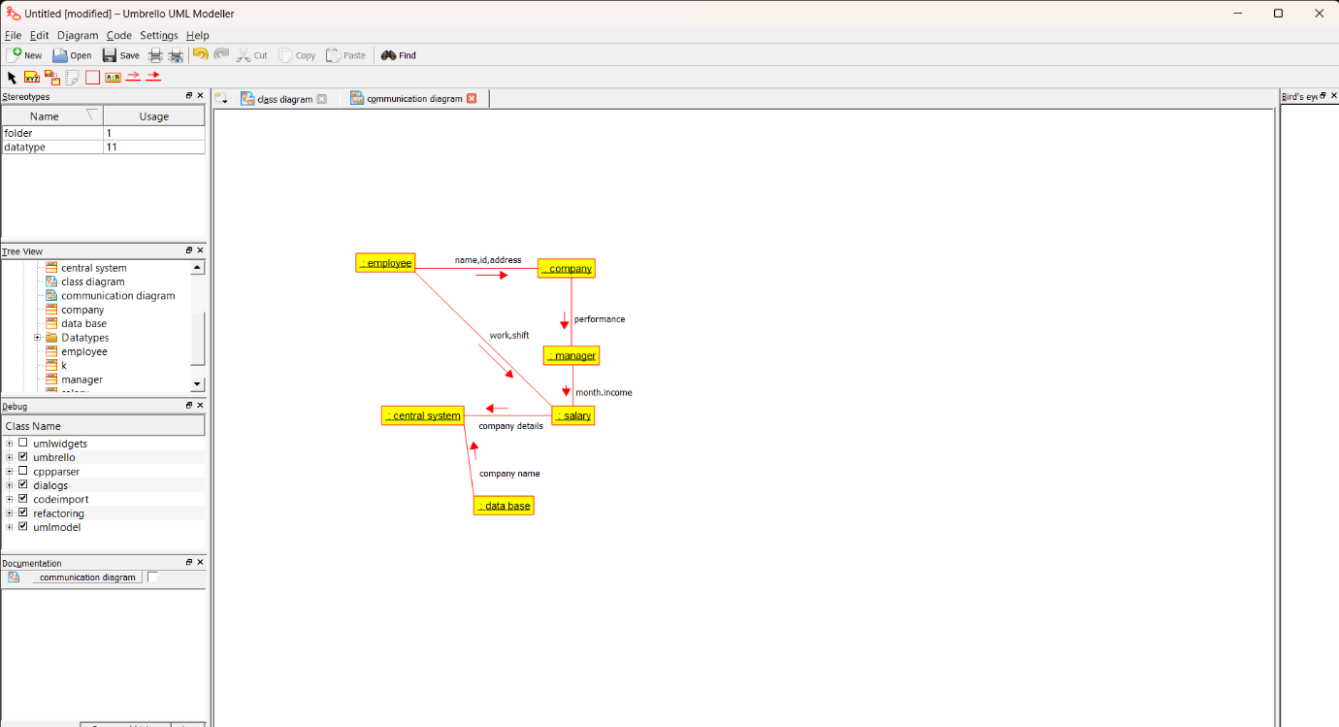

**PACKAGE DIAGRAM:**

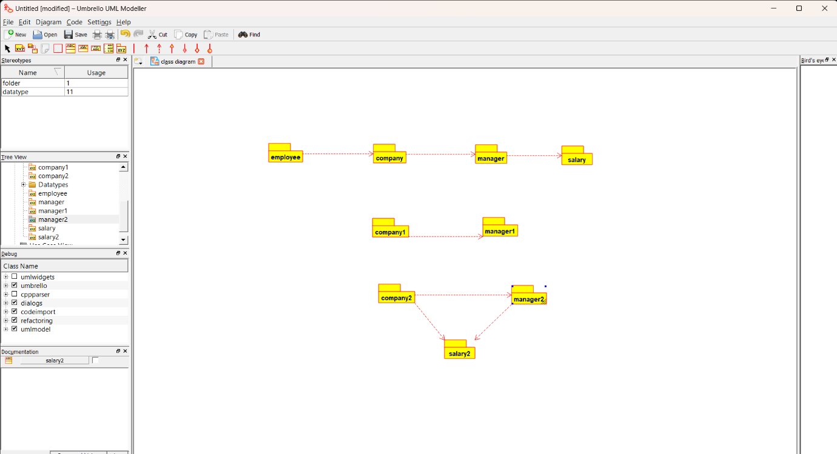

**USE CASE DIAGRAM :**

